# Import pandas using the alias pd
import pandas as pd

# Print the values of homelessness
print(homelessness.values)

# Print the column index of homelessness
print(homelessness.columns)

# Print the row index of homelessness
print(homelessness.index)

# Print the head of the homelessness data
print(homelessness.head())

SORT
To sort with respect to smallest size
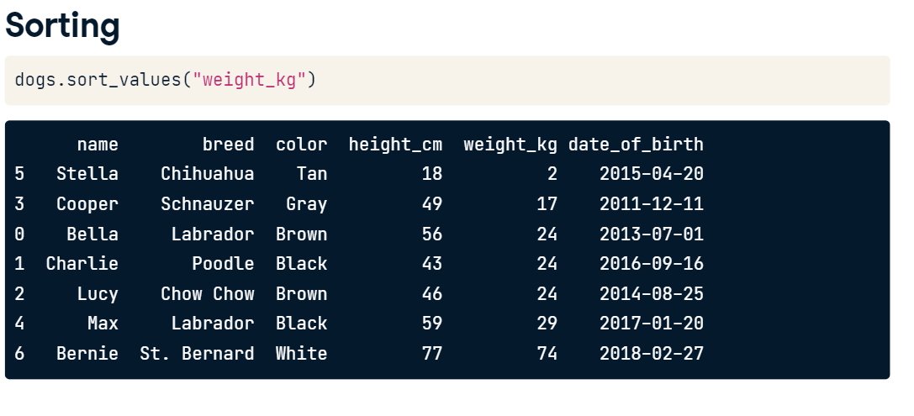
QUIZ
# Sort homelessness by individuals
homelessness_ind = homelessness.sort_values("individuals")
# Print the top few rows
print(homelessness_ind.head())

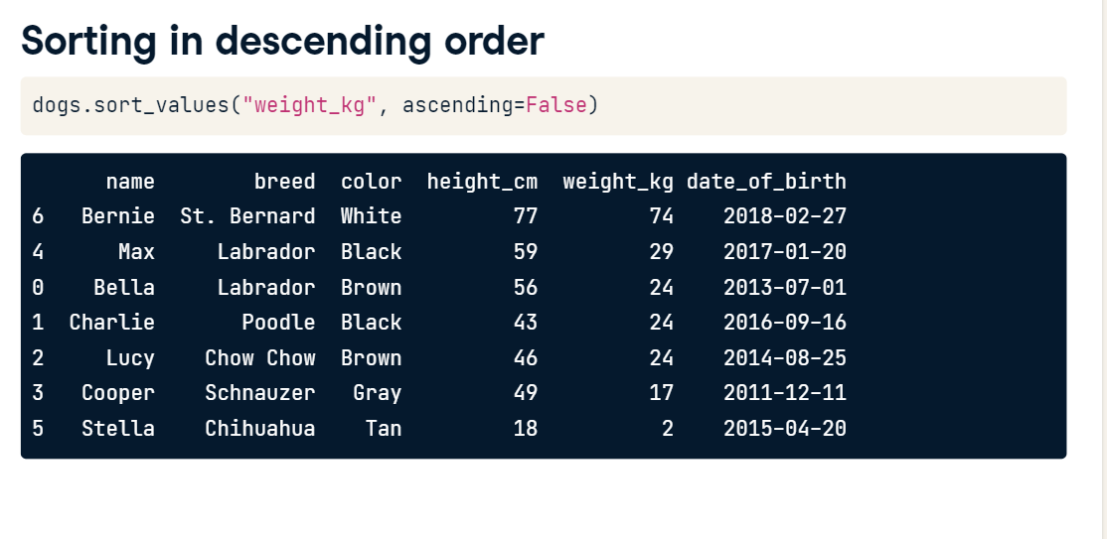
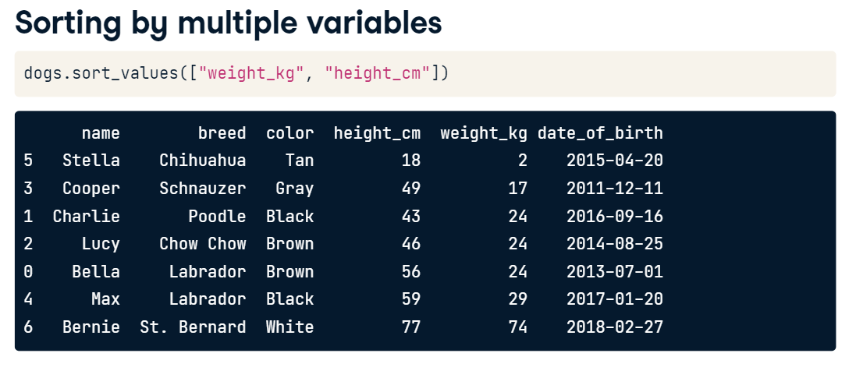

# Sort homelessness by descending family members
homelessness_fam = homelessness.sort_values("family_members", ascending =False)

# Print the top few rows
homelessness_fam.head()

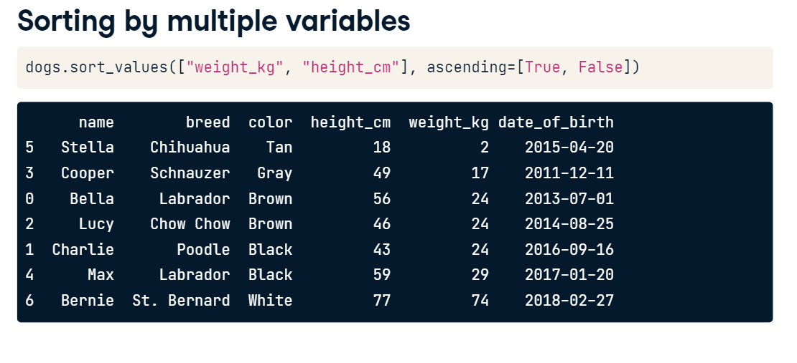
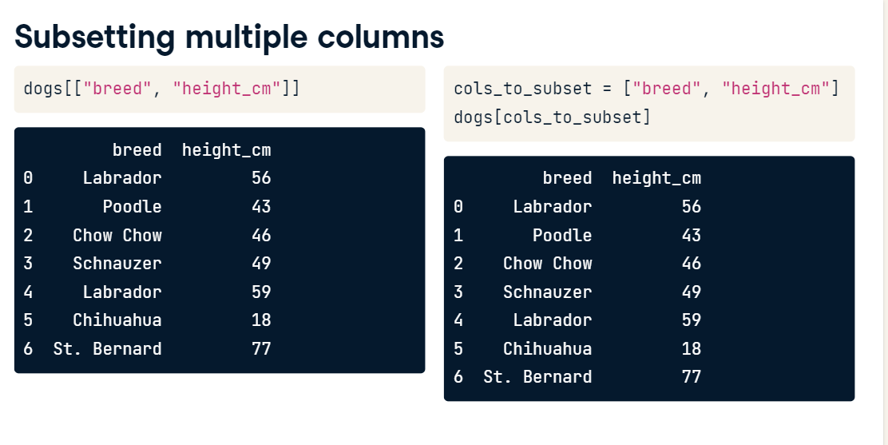
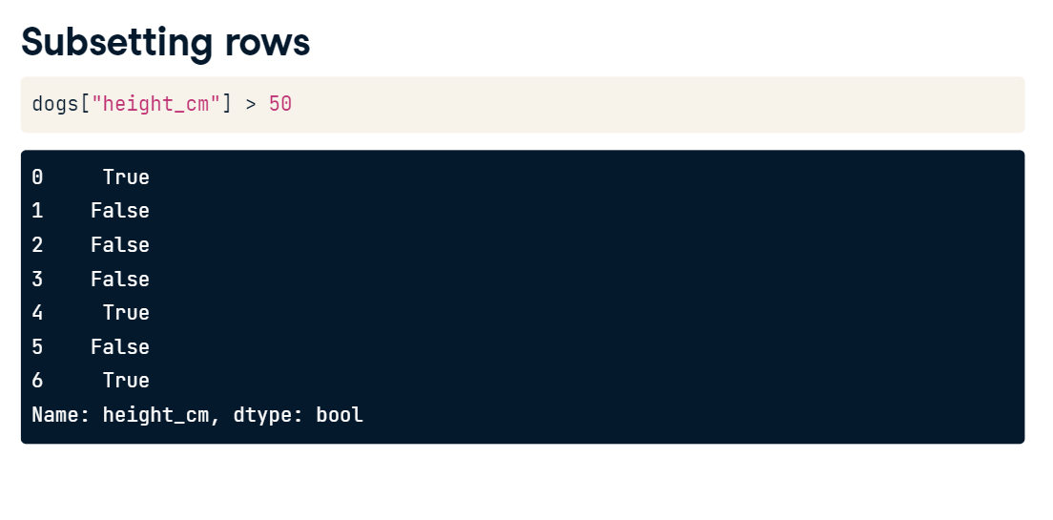
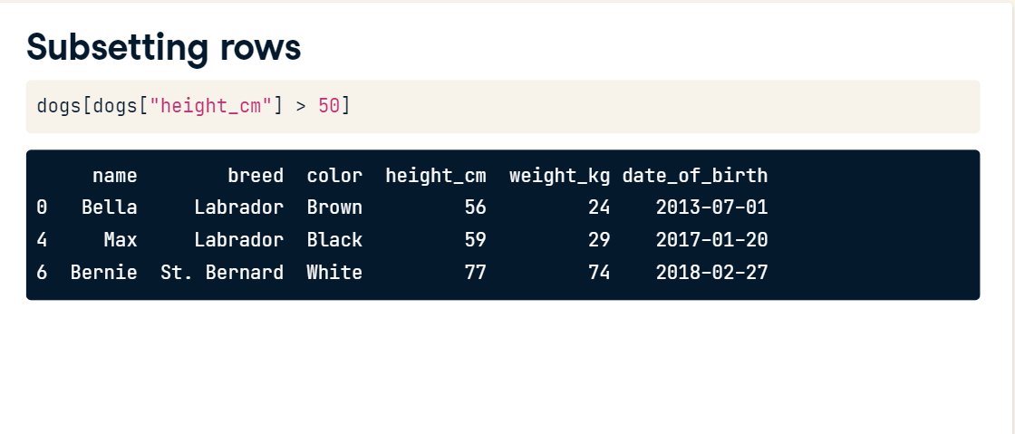
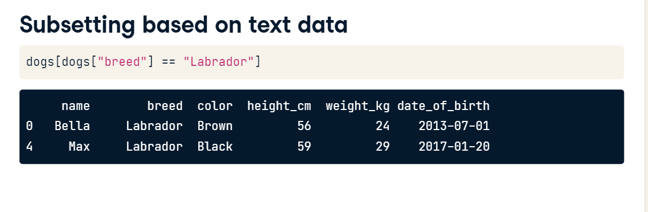
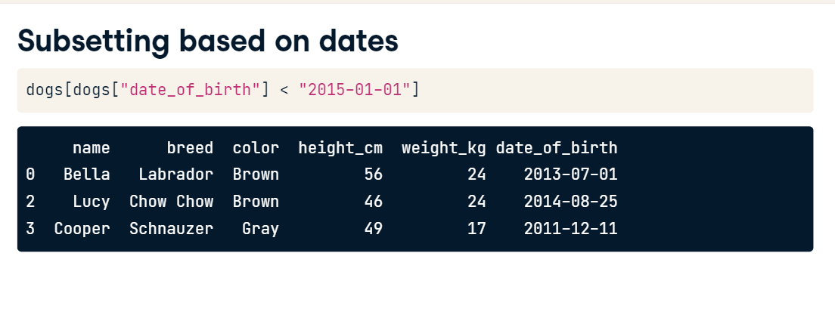
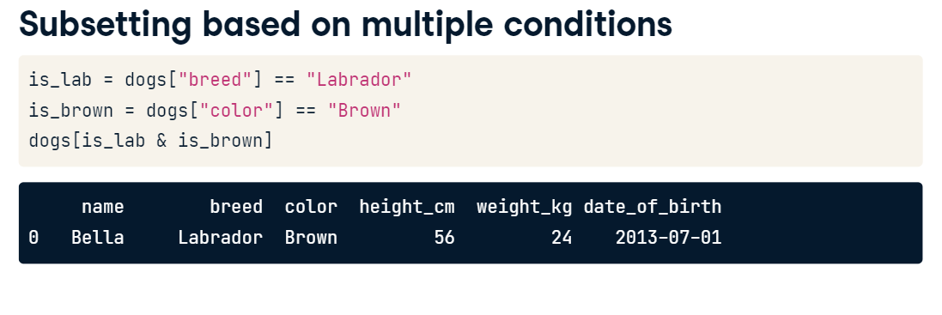
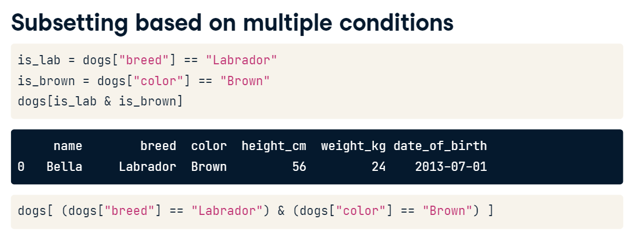
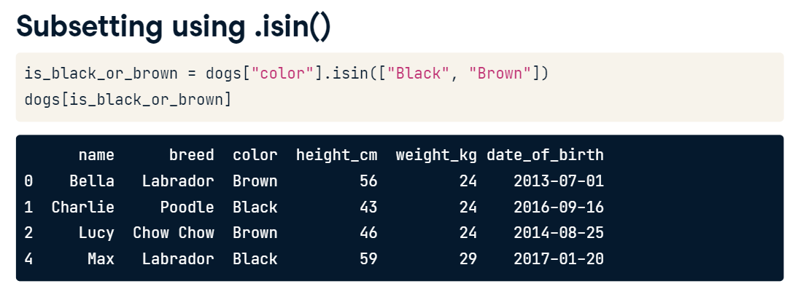
# Sort homelessness by region, then descending family members
homelessness_reg_fam = homelessness.sort_values(["region", "family_members"], ascending =[True, False])

# Print the top few rows
print(homelessness_reg_fam.head())

# Select the individuals column
individuals = homelessness["individuals"]

# Print the head of the result
print(individuals)

# Select the state and family_members columns
state_fam = homelessness[["state","family_members"]]

# Print the head of the result
print(state_fam.head())

# Select only the individuals and state columns, in that order
ind_state = homelessness[["individuals","state" ]]

# Print the head of the result
print(ind_state.head())

# Filter for rows where individuals is greater than 10000
ind_gt_10k =homelessness[(homelessness["individuals"]>10000)]

# See the result
print(ind_gt_10k)

# Filter for rows where region is Mountain
mountain_reg = homelessness[(homelessness["region"]=="Mountain")]

# See the result
print(mountain_reg)

# Filter for rows where family_members is less than 1000
# and region is Pacific
fam_lt_1k_pac = homelessness[(homelessness["family_members"]< 1000) & (homelessness["region"]=="Pacific")]

# See the result
print(fam_lt_1k_pac)

Subsetting rows by categorical variables
Subsetting data based on a categorical variable often involves using the "or" operator (|) to select rows from multiple categories. This can get tedious when you want all states in one of three different regions, for example. Instead, use the .isin() method, which will allow you to tackle this problem by writing one condition instead of three separate ones.
colors = ["brown", "black", "tan"]
condition = dogs["color"].isin(colors)
dogs[condition]

# Subset for rows in South Atlantic or Mid-Atlantic regions
#regions_1 = ["South Atlantic", "Mid-Atlantic"]
#south_mid_atlantic = homelessness ["region"].isin(regions_1)
south_mid_atlantic= homelessness[(homelessness["region"] == "South Atlantic") | (homelessness["region"] == "Mid-Atlantic")]

# See the result
print(south_mid_atlantic)

# The Mojave Desert states
canu = ["California", "Arizona", "Nevada", "Utah"]

# Filter for rows in the Mojave Desert states
mojave_homelessness = homelessness[homelessness["state"].isin(canu)]

# See the result
print(mojave_homelessness)

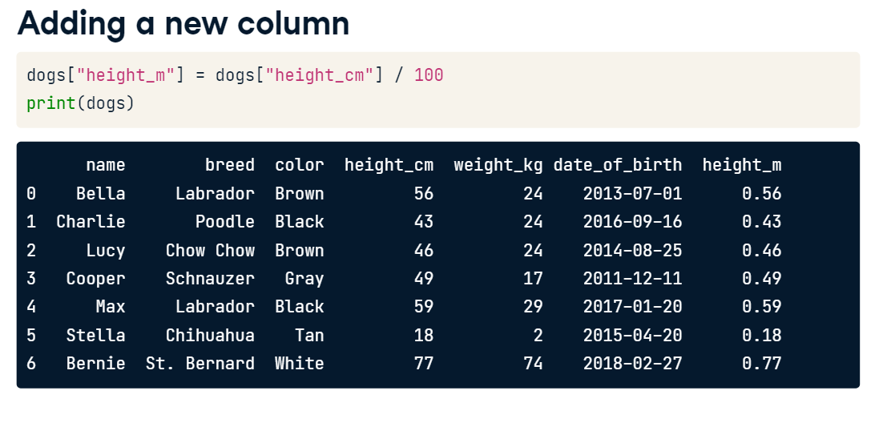
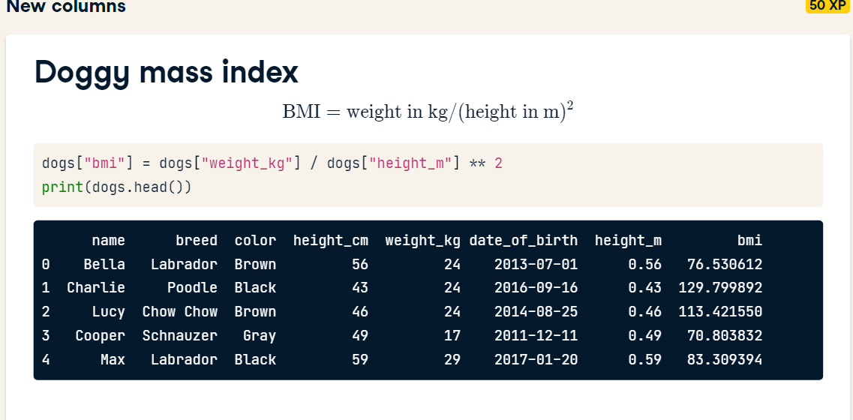
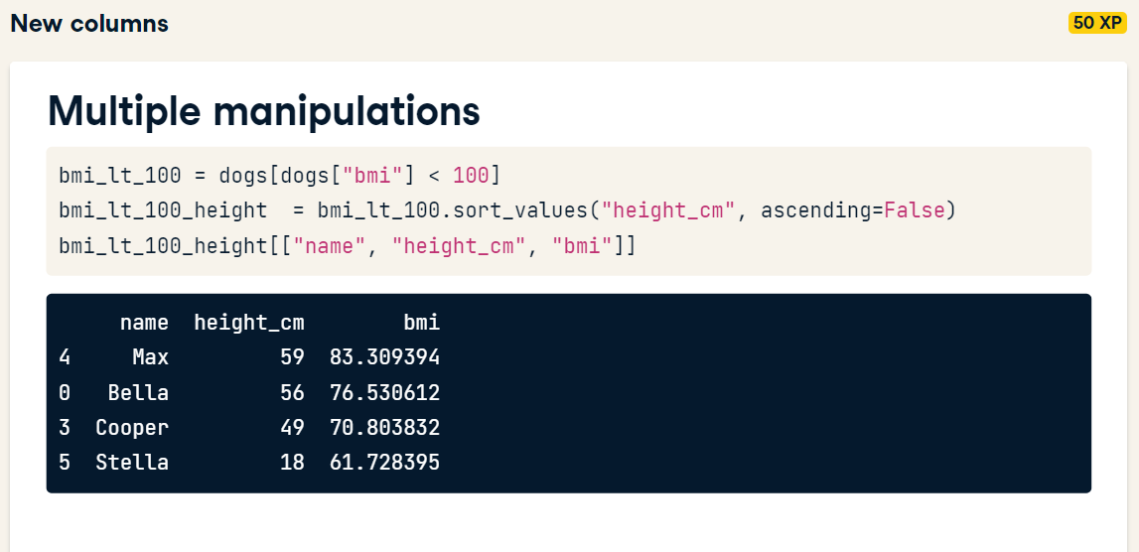
- Add a new column to homelessness, named total, containing the sum of the individuals and family_members columns.
- Add another column to homelessness, named p_individuals, containing the proportion of homeless people in each state who are individuals.
- # Add total col as sum of individuals and family_members
- homelessness['total']= homelessness["individuals"] + homelessness["family_members"]

- # Add p_individuals col as proportion of total that are individuals
- homelessness["p_individuals"]=homelessness["individuals"]/ homelessness["total"]

- # See the result
- print(homelessness)

# Create indiv_per_10k col as homeless individuals per 10k state pop
homelessness["indiv_per_10k"] = 10000 * homelessness["individuals"] / homelessness["state_pop"]

# Subset rows for indiv_per_10k greater than 20
high_homelessness = homelessness[homelessness["indiv_per_10k"] > 20]

# Sort high_homelessness by descending indiv_per_10k
high_homelessness_srt = high_homelessness.sort_values("indiv_per_10k", ascending=False)

# From high_homelessness_srt, select the state and indiv_per_10k cols
result = high_homelessness_srt[["state", "indiv_per_10k"]]

# See the result
print(result)

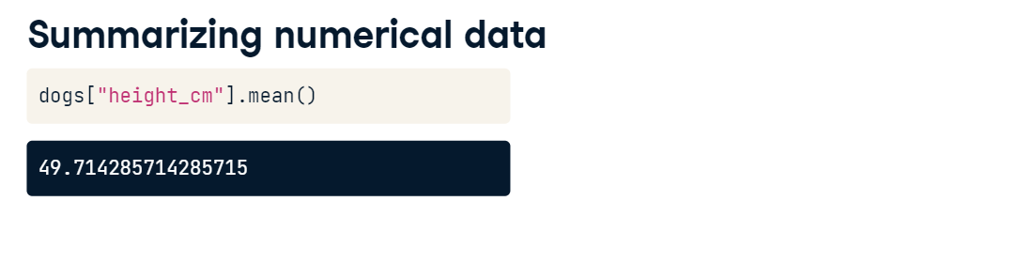
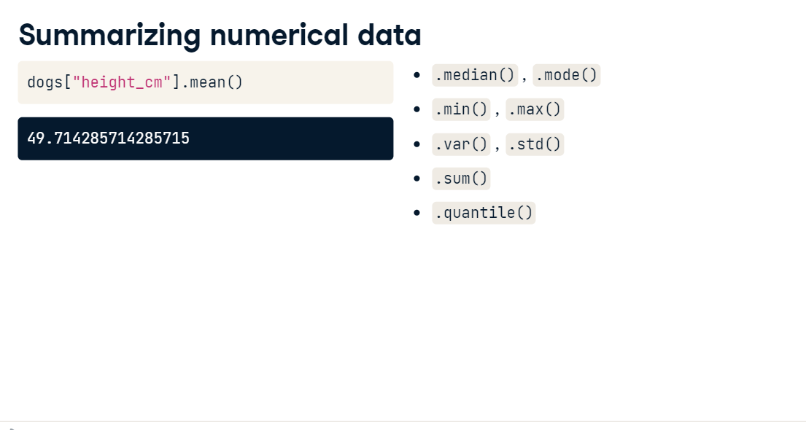
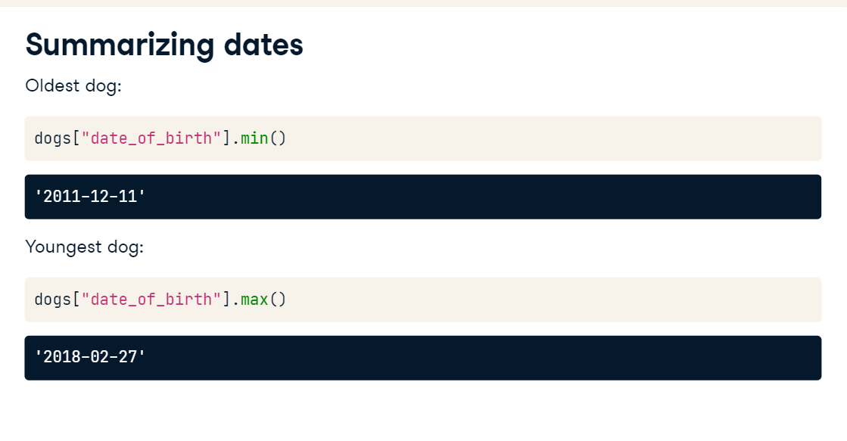

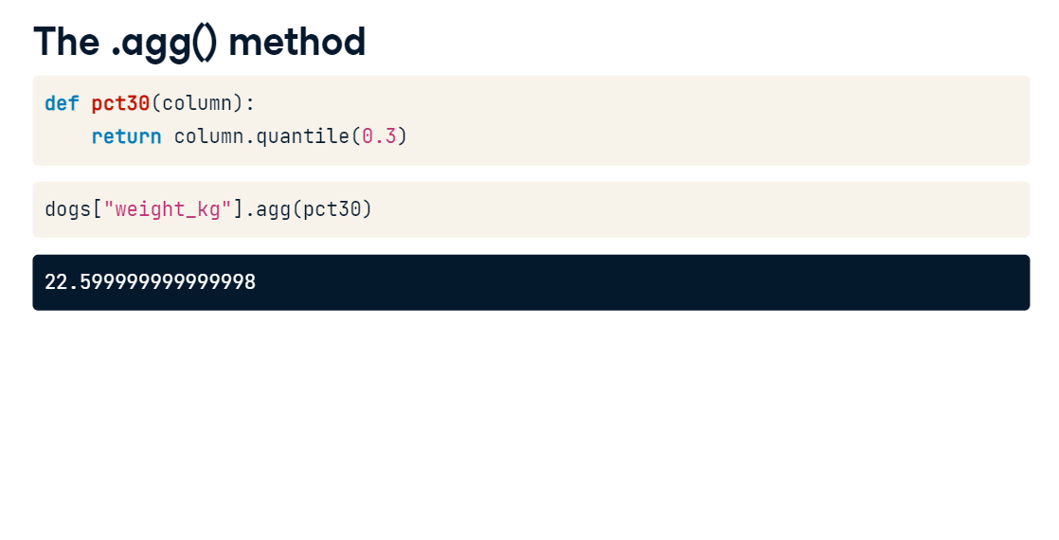

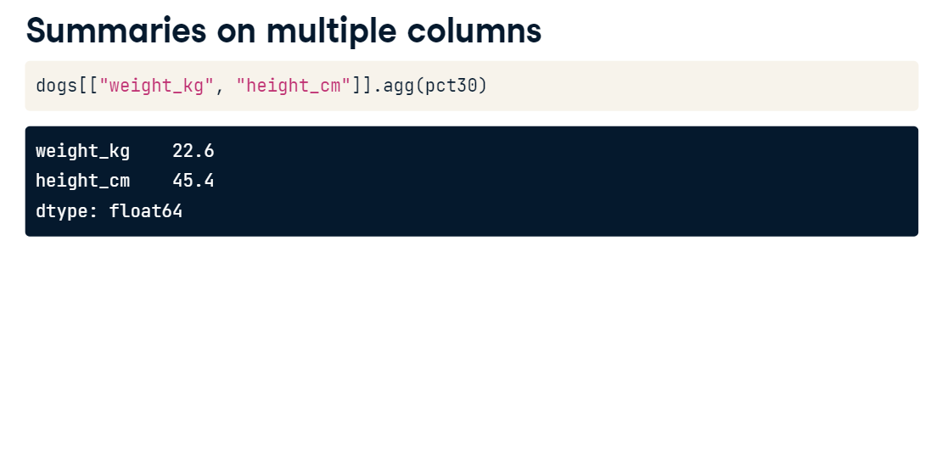
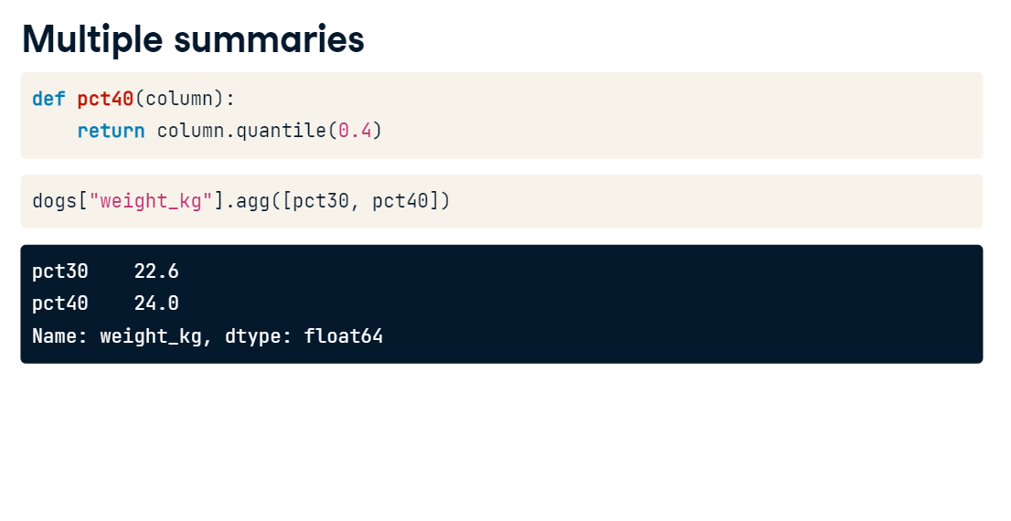
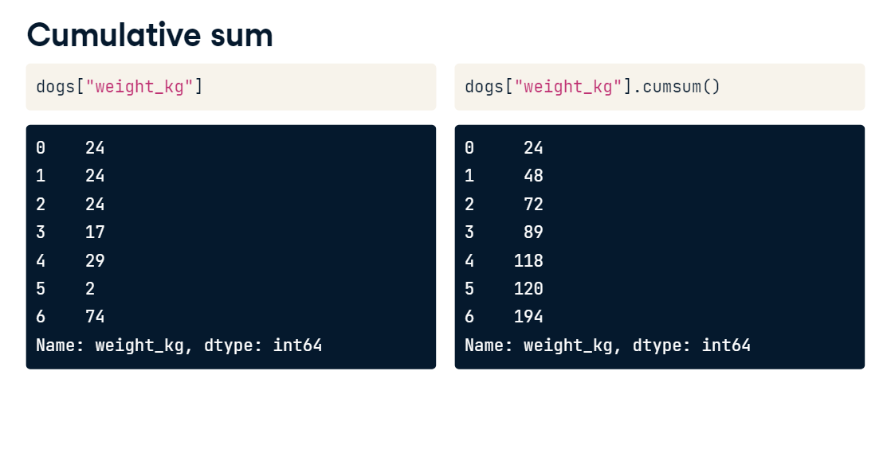
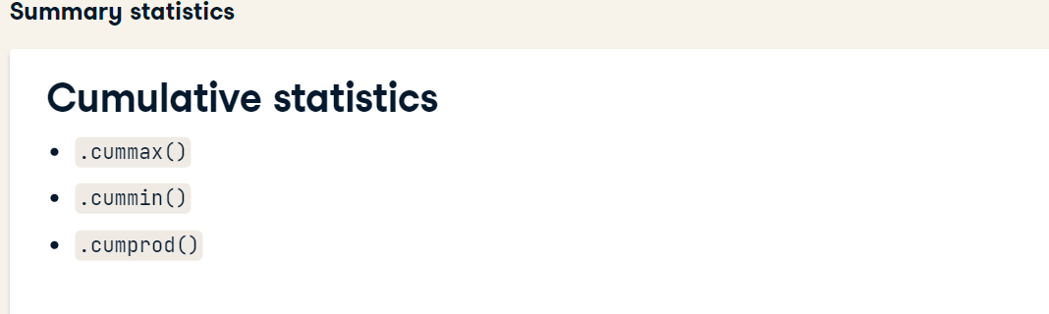
=RIGHT(F2,LEN(F2)-1)
- Explore your new DataFrame first by printing the first few rows of the sales DataFrame.
- Print information about the columns in sales.
- Print the mean of the weekly_sales column.
- Print the median of the weekly_sales column.
- # Print the maximum of the date column
- print(sales["date"].max())

- # Print the minimum of the date column
- print(sales["date"].min())

Efficient summaries
While pandas and NumPy have tons of functions, sometimes, you may need a different function to summarize your data.
The .agg() method allows you to apply your own custom functions to a DataFrame, as well as apply functions to more than one column of a DataFrame at once, making your aggregations super-efficient. For example,
df['column'].agg(function)
In the custom function for this exercise, "IQR" is short for inter-quartile range, which is the 75th percentile minus the 25th percentile. It's an alternative to standard deviation that is helpful if your data contains outliers.

# A custom IQR function
def iqr(column):
return column.quantile(0.75) - column.quantile(0.25)

# Print IQR of the temperature_c column
print(sales["temperature_c"].agg(iqr))

# Sort sales_1_1 by date
sales_1_1 = sales_1_1.sort_values("date")

# Get the cumulative sum of weekly_sales, add as cum_weekly_sales col
sales_1_1["cum_weekly_sales"] = sales_1_1["weekly_sales"].cumsum()

# Get the cumulative max of weekly_sales, add as cum_max_sales col
sales_1_1["cum_max_sales"] = sales_1_1["weekly_sales"].cummax()

# See the columns you calculated
print(sales_1_1[["date", "weekly_sales", "cum_weekly_sales", "cum_max_sales"]])

REMOVING DUPLICATES
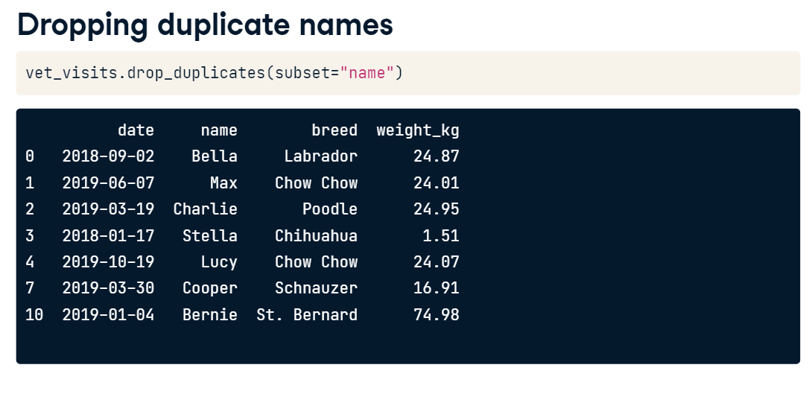
REMOVING DUPLICATES AND ENSURING NAMES OR VALUES WHICH ARE NOT ACTUALLY DUPLICATES ARE RETAINED , DO THIS :
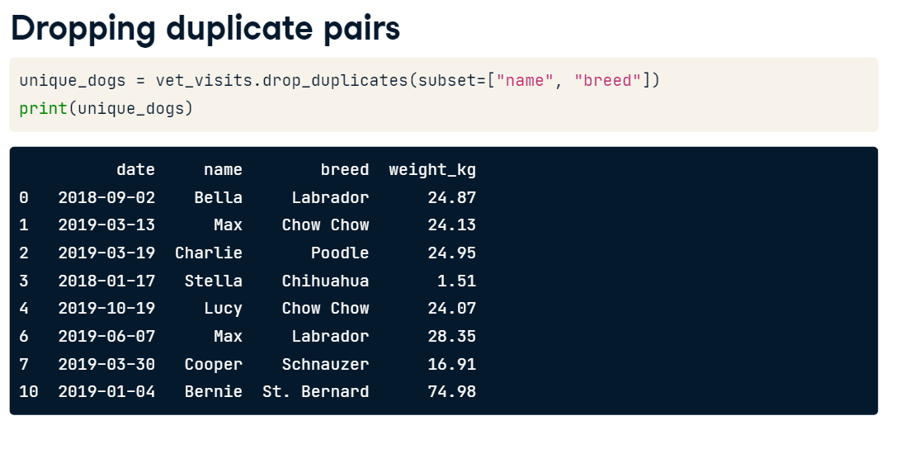
TO COUNT VALUES
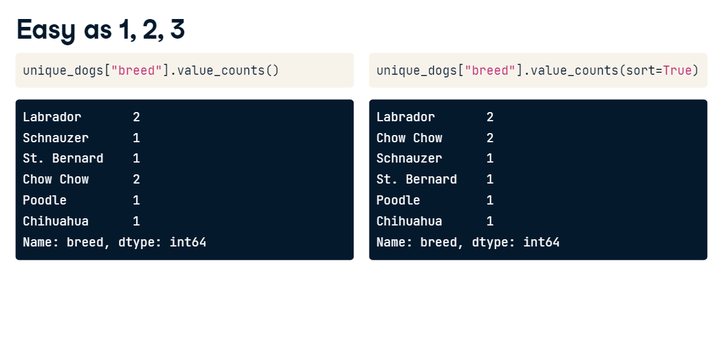TO CONVERT EACH COUNT TO PERCENTAGE OF THE TOTAL
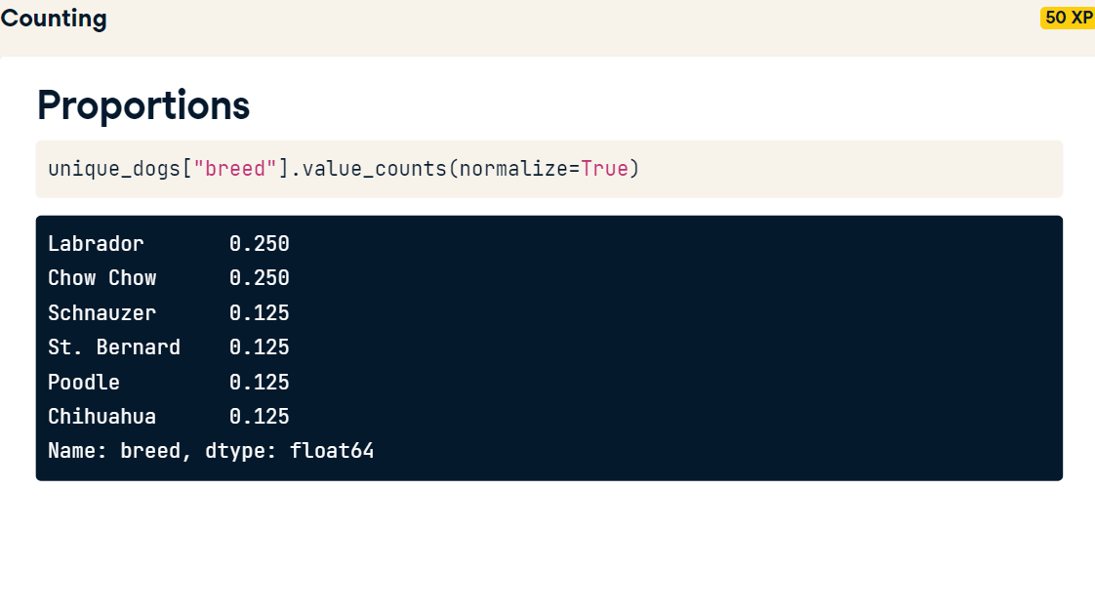
- Count the number of stores of each store type in store_types.
- Count the proportion of stores of each store type in store_types.
- Count the number of different departments in store_depts, sorting the counts in descending order.
- Count the proportion of different departments in store_depts, sorting the proportions in descending order.
store_types

- Remove rows of sales with duplicate pairs of store and type and save as store_types and print the head.
- Remove rows of sales with duplicate pairs of store and department and save as store_depts and print the head.
- Subset the rows that are holiday weeks using the is_holiday column, and drop the duplicate dates, saving as holiday_dates.
- Select the date column of holiday_dates, and print.
- # Drop duplicate store/type combinations
- store_types = sales.drop_duplicates(subset=["store", "type"])
- print(store_types.head())

- # Drop duplicate store/department combinations
- store_depts = sales.drop_duplicates(subset=["store", "department"])
- print(store_depts.head())

- # Subset the rows where is_holiday is True and drop duplicate dates
- holiday_dates = sales[sales["is_holiday"]==True].drop_duplicates(subset="date")

- # Print date col of holiday_dates
- print(holiday_dates["date"])

# Count the number of stores of each type
store_counts = store_types["type"].value_counts()
print(store_counts)

# Get the proportion of stores of each type
store_props = store_types["type"].value_counts(normalize=True)
print(store_props)

# Count the number of each department number and sort
dept_counts_sorted = store_depts["department"].value_counts(sort=True)
print(dept_counts_sorted)

# Get the proportion of departments of each number and sort
dept_props_sorted = store_depts["department"].value_counts(sort=True, normalize=True)
print(dept_props_sorted)

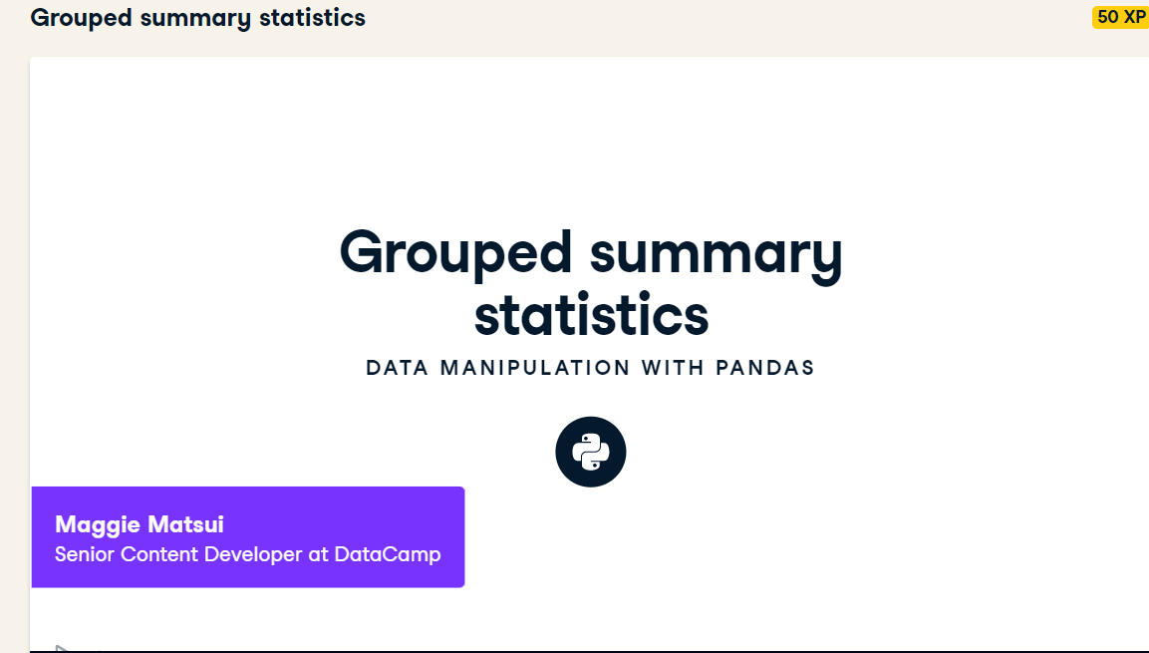
SUMMARIZING BY EACH ATTRIBUTE IS QUITE DEMANDING AND IT COULD LEAD TO ERRORS
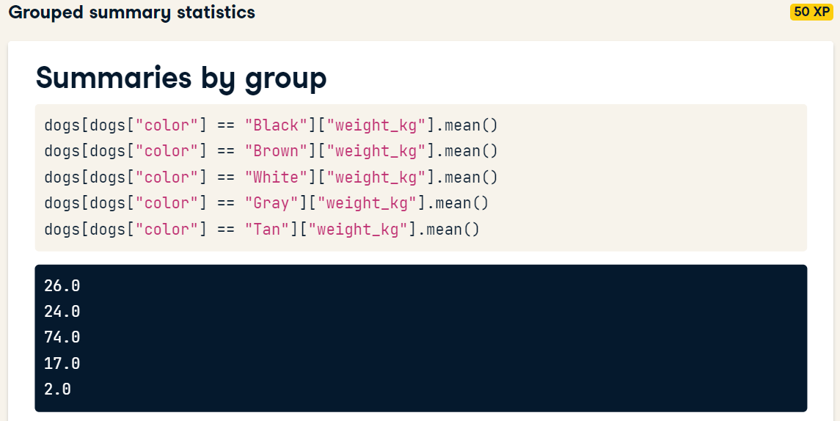

YOU CAN USE THE “GROUP BY”
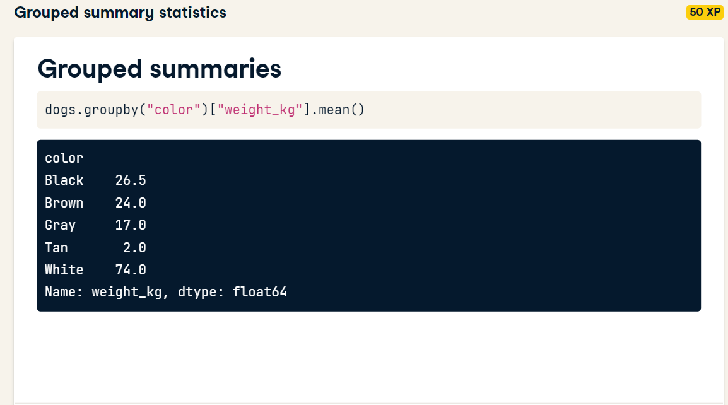
- Calculate the total weekly_sales over the whole dataset.
- Subset for type "A" stores, and calculate their total weekly sales.
- Do the same for type "B" and type "C" stores.
- Combine the A/B/C results into a list, and divide by sales_all to get the proportion of sales by type.
- # Calc total weekly sales
- sales_all = sales["weekly_sales"].sum()

- # Subset for type A stores, calc total weekly sales
- sales_A = sales[sales["type"] == "A"]["weekly_sales"].sum()

- # Subset for type B stores, calc total weekly sales
- sales_B = sales[sales["type"] == "B"]["weekly_sales"].sum()

- # Subset for type C stores, calc total weekly sales
- sales_C = sales[sales["type"] == "C"]["weekly_sales"].sum()

- # Get proportion for each type
- sales_propn_by_type = [sales_A, sales_B, sales_C] / sales_all
- print(sales_propn_by_type)

Calculations with .groupby()
The .groupby() method makes life much easier. In this exercise, you'll perform the same calculations as last time, except you'll use the .groupby() method. You'll also perform calculations on data grouped by two variables to see if sales differ by store type depending on if it's a holiday week or not.
- Group sales by "type", take the sum of "weekly_sales", and store as sales_by_type.
- Calculate the proportion of sales at each store type by dividing by the sum of sales_by_type. Assign to sales_propn_by_type.
- print(sales_propn_by_type)

- Group sales by "type" and "is_holiday", take the sum of weekly_sales, and store as sales_by_type_is_holiday.
- # From previous step
- sales_by_type = sales.groupby("type")["weekly_sales"].sum()

- # Group by type and is_holiday; calc total weekly sales
- sales_by_type_is_holiday = sales.groupby(["type","is_holiday"])["weekly_sales"].sum()
- print(sales_by_type_is_holiday)

Multiple grouped summaries
Earlier in this chapter, you saw that the .agg() method is useful to compute multiple statistics on multiple variables. It also works with grouped data. NumPy, which is imported as np, has many different summary statistics functions, including: np.min, np.max, np.mean, and np.median.

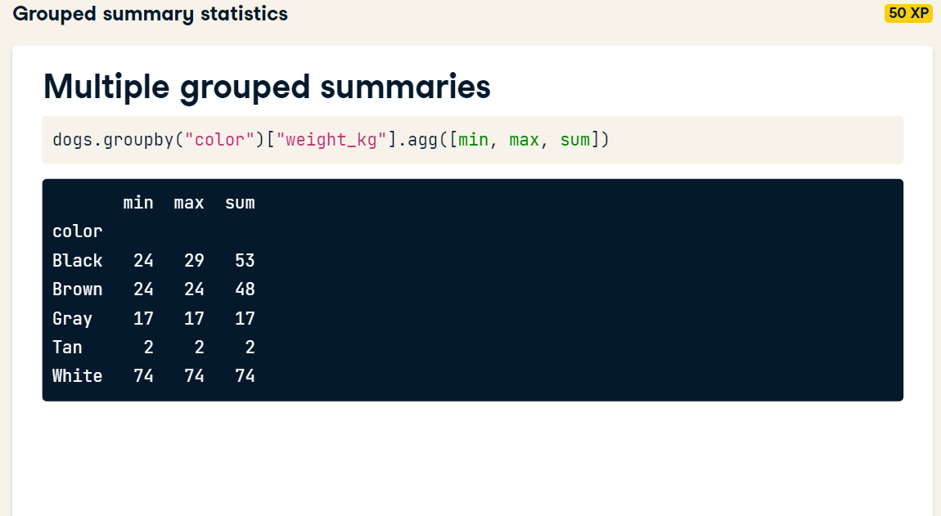

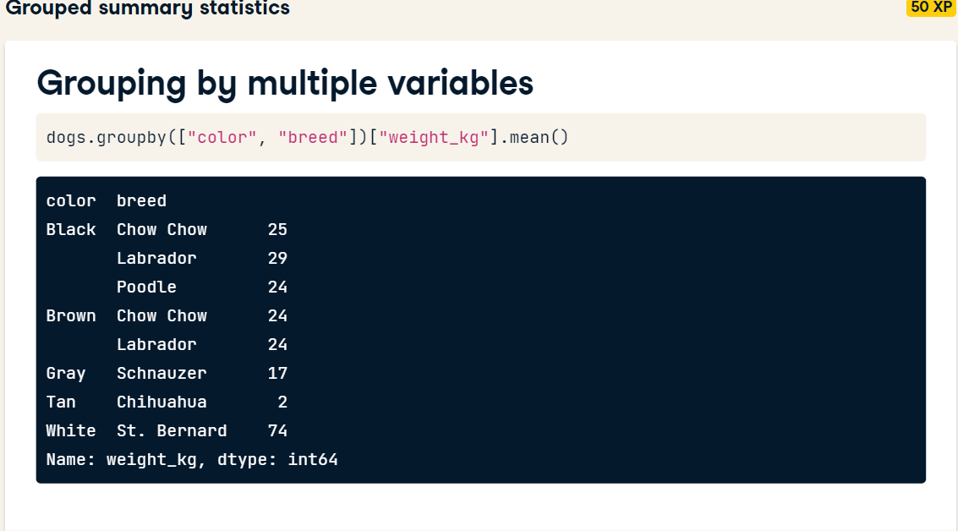
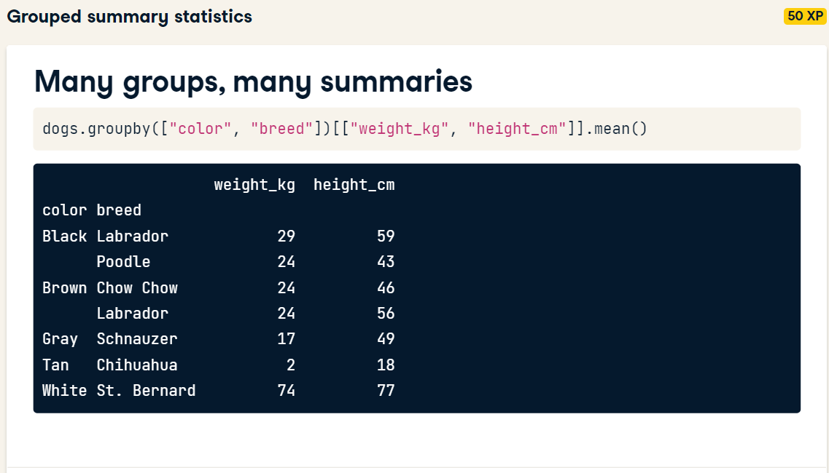
- Import numpy with the alias np.
- Get the min, max, mean, and median of weekly_sales for each store type using .groupby() and .agg(). Store this as sales_stats. Make sure to use numpy functions!
- Get the min, max, mean, and median of unemployment and fuel_price_usd_per_l for each store type. Store this as unemp_fuel_stats.
- # Import numpy with the alias np
- import numpy as np

- # For each store type, aggregate weekly_sales: get min, max, mean, and median
- sales_stats = sales.groupby("type")["weekly_sales"].agg([np.min, np.max, np.mean, np.median])

- # Print sales_stats
- print(sales_stats)

- # For each store type, aggregate unemployment and fuel_price_usd_per_l: get min, max, mean, and median
- unemp_fuel_stats = sales.groupby("type")[["unemployment", "fuel_price_usd_per_l"]].agg([np.min, np.max, np.mean, np.median])

- # Print unemp_fuel_stats
- print(unemp_fuel_stats)



BY DEFAULT PIVOT TABLE IN PANDAS TAKES THE MEAN OF THE VALUES YOU PUT IN THE ATTRIBUTE

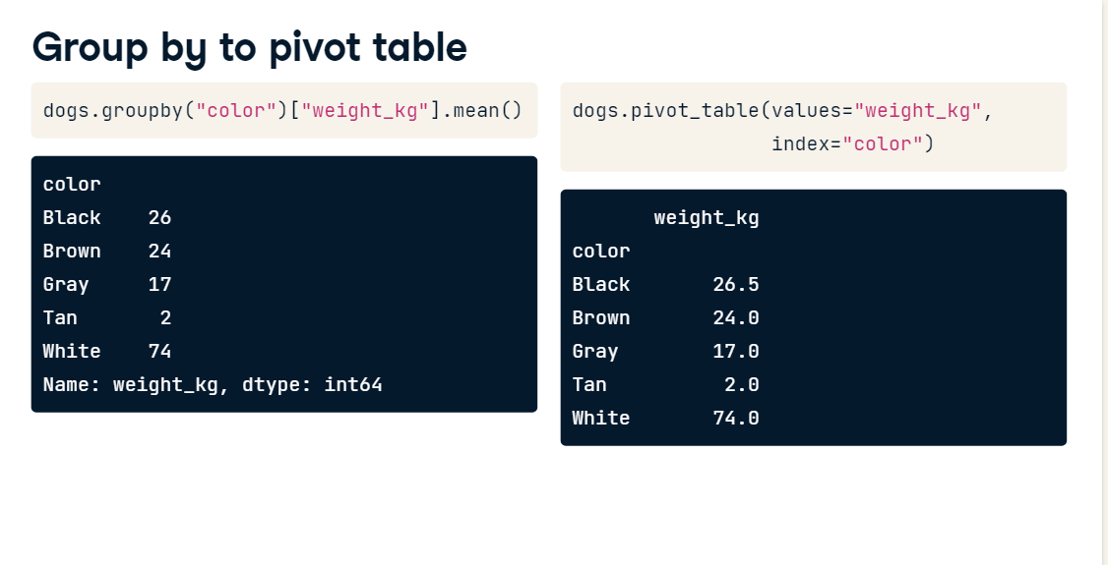
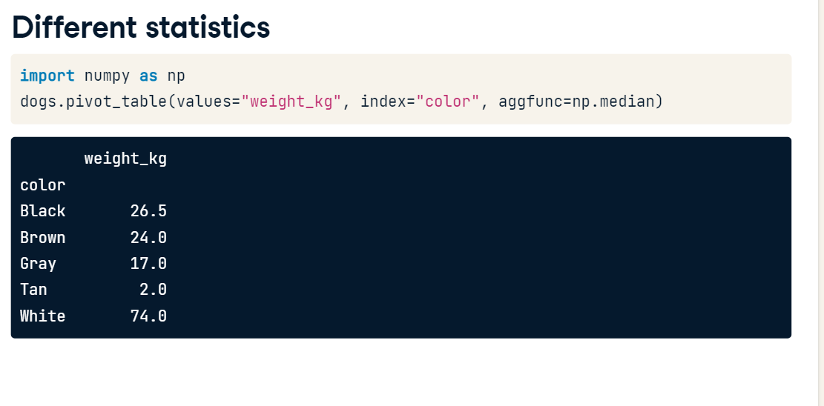
TO GET MULTIPLE SUMMARY STATISTICS
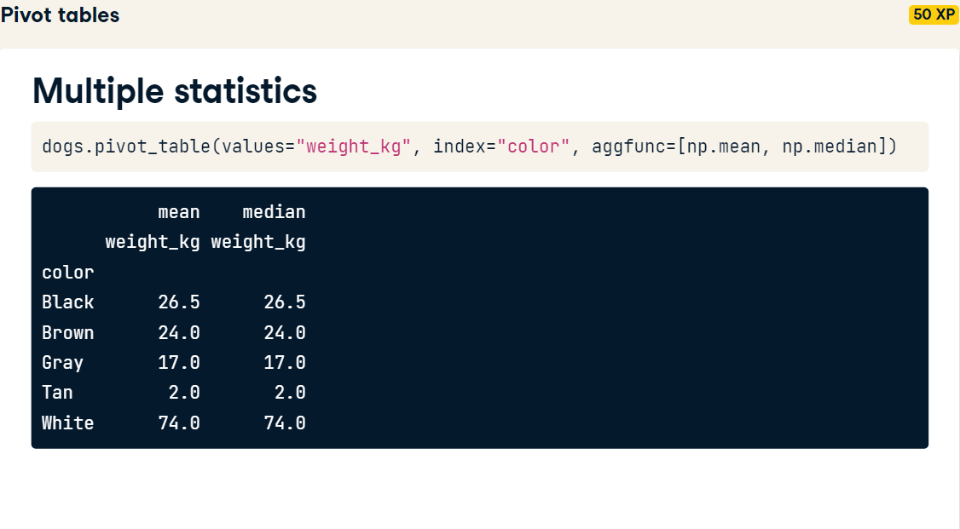
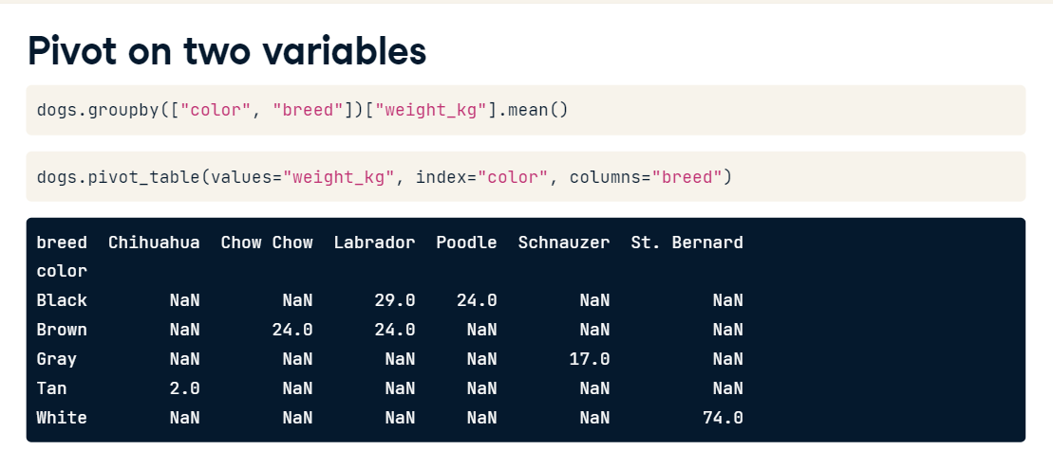
FILL THE NAN DATA POINTS WITH “0”
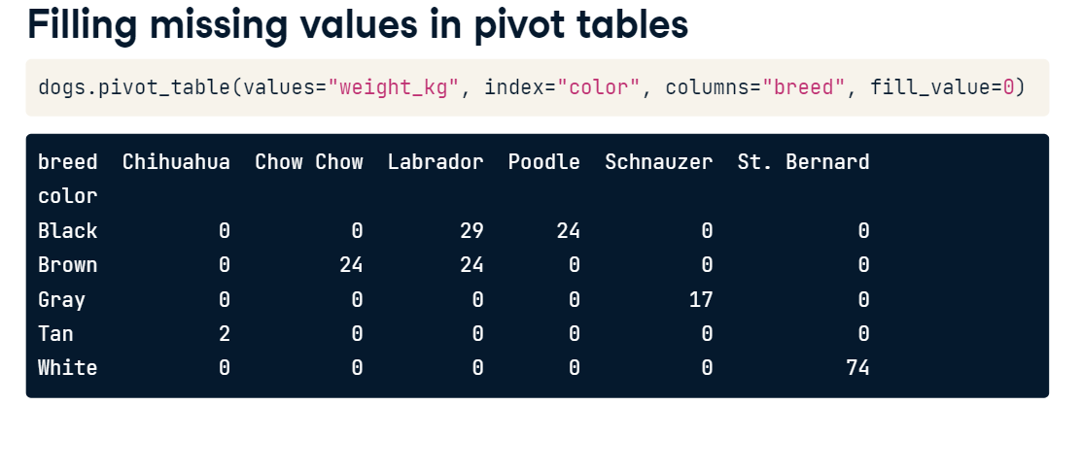
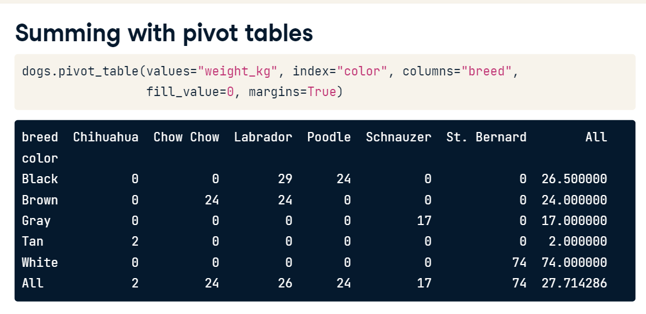
# Pivot for mean weekly_sales for each store type
mean_sales_by_type = sales.pivot_table(values="weekly_sales", index ="type")

# Print mean_sales_by_type
print(mean_sales_by_type)

- Get the mean and median (using NumPy functions) of weekly_sales by type using .pivot_table() and store as mean_med_sales_by_type.
- # Import NumPy as np
- import numpy as np

- # Pivot for mean and median weekly_sales for each store type
- mean_med_sales_by_type = sales.pivot_table(values = "weekly_sales", index = "type", aggfunc=([np.mean, np.median]))

- # Print mean_med_sales_by_type
- print(mean_med_sales_by_type)

  - Print the mean weekly_sales by department and type, filling in any missing values with 0.
- 2
  - Print the mean weekly_sales by department and type, filling in any missing values with 0 and summing all rows and columns.

# Print the mean weekly_sales by department and type; fill missing values with 0s; sum all rows and cols
print(sales.pivot_table(values="weekly_sales", index="department", columns="type", fill_value = 0, margins = True))

# to convert str datatype of a column in a dataset to int64 using apply method
df[['A', 'C']] = df[['A', 'C']].apply(pd.to_numeric)
print(df.dtypes)

